- To flash the firmware using QMK Toolbox, the keyboard needs to enter DFU mode (Device Firmware Update).

Method to enter DFU mode: While in wired mode, long - press the ESC key and then plug in the cable (universal method).

After opening QMK Toolbox, when the keyboard enters DFU mode, yellow text will appear on the screen, and there will also be the words "DFU Device connected".
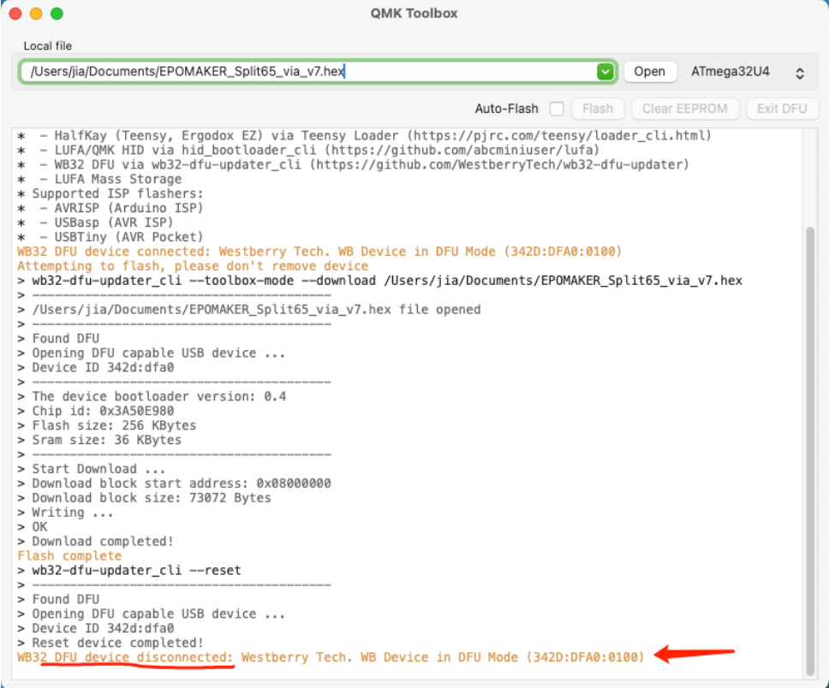

- After connecting, click "Open" to open the folder and find the.hex or.bin file corresponding to the product.
QMK Toolbox only supports.hex or.bin files. ( ❗❗Not JSON, not JSON, not JSON)
After opening the file, click "Flash".

❗❗During the flashing process, do not touch the keyboard, as it may cause the flashing to fail and turn the keyboard into a "brick".
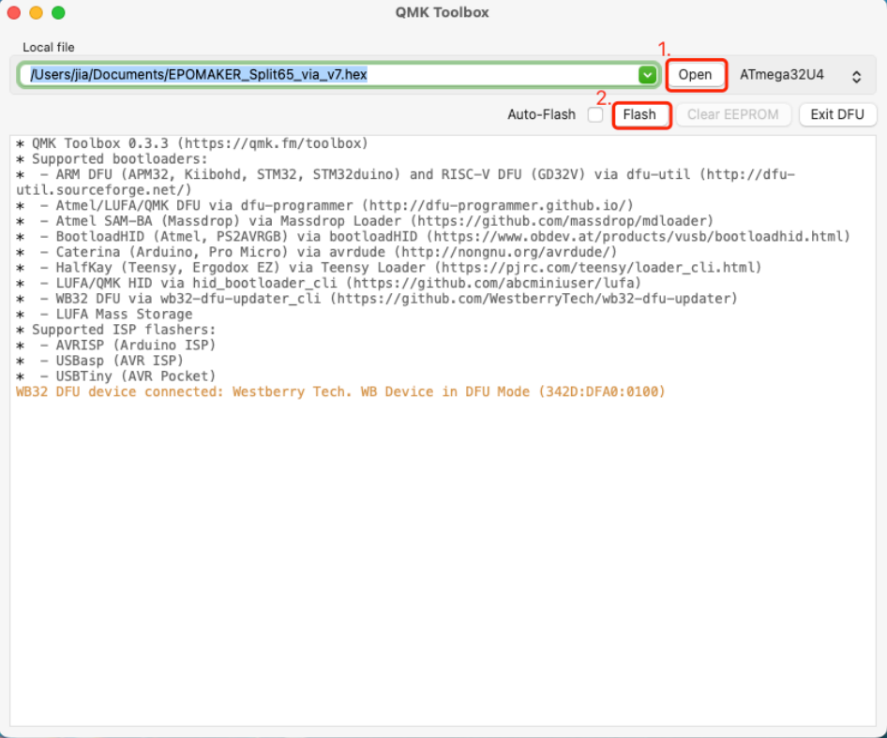

- Wait until you see a new line of yellow text indicating "Flash Complete".

Click "Exit DFU" in the upper - right corner to make the keyboard exit DFU mode. Then unplug the cable and reconnect it.

When the keyboard backlight turns on, the firmware flashing is completed.
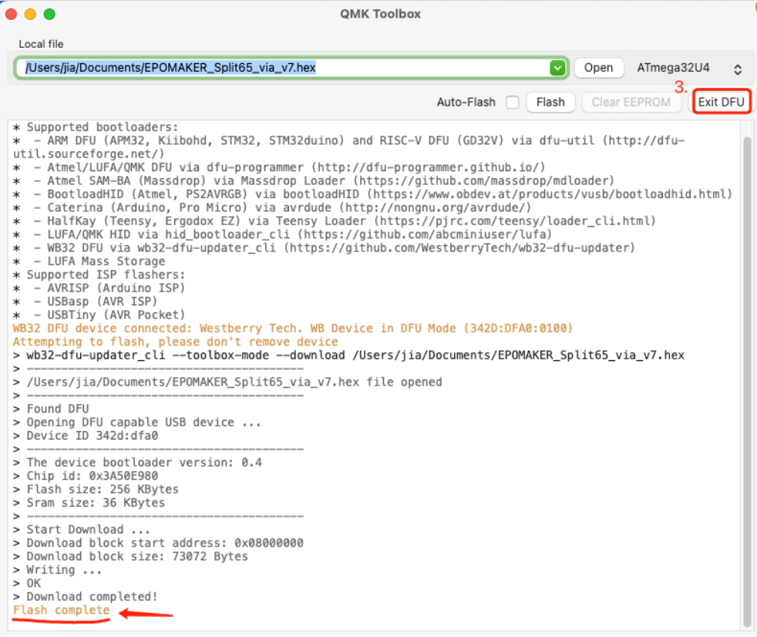

- Click "Exit DFU" in the upper - right corner, and the keyboard will exit DFU mode. Yellow text will appear again, reading "DFU Device Disconnected".

When the keyboard backlight turns on, the firmware flashing is completed.
